[[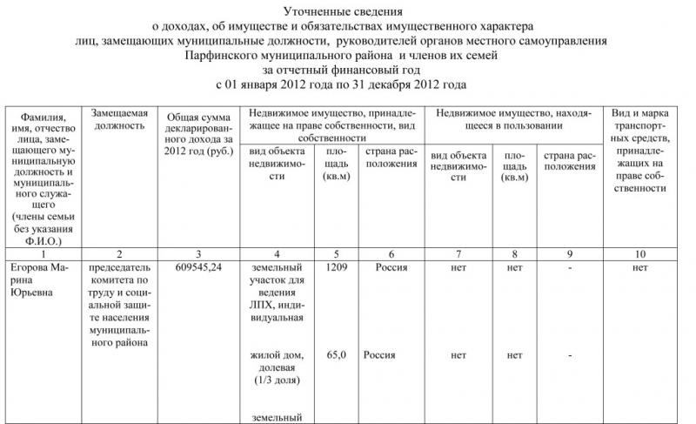](http://xn--80aqaedrljl1a.xn--p1ai/wp-content/uploads/Utochnennye-svedeniya-o-doxodax-rukovoditelej-organov-mestnogo-samoupravleniya-1.jpg)](http://xn--80aqaedrljl1a.xn--p1ai/wp-content/uploads/Utochnennye-svedeniya-o-doxodax-rukovoditelej-organov-mestnogo-samoupravleniya-1.jpg)[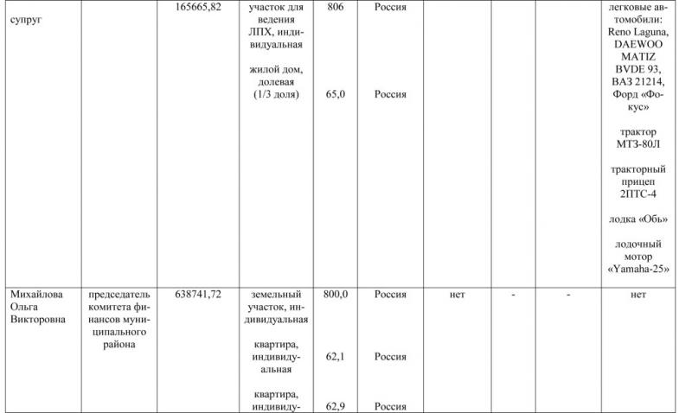](http://xn--80aqaedrljl1a.xn--p1ai/wp-content/uploads/Utochnennye-svedeniya-o-doxodax-rukovoditelej-organov-mestnogo-samoupravleniya-2.jpg)[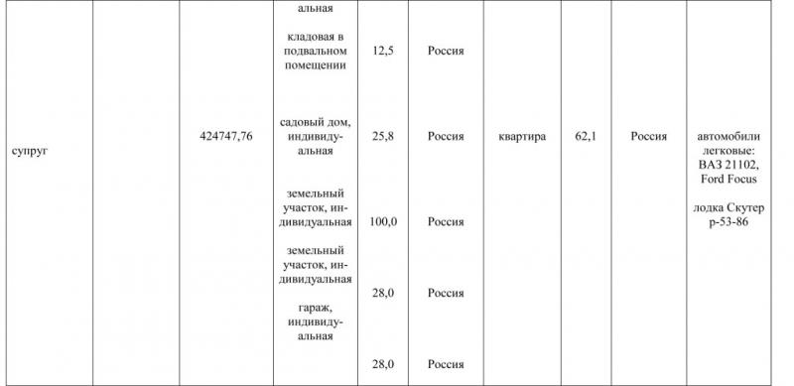](http://xn--80aqaedrljl1a.xn--p1ai/wp-content/uploads/Utochnennye-svedeniya-o-doxodax-rukovoditelej-organov-mestnogo-samoupravleniya-3.jpg)