[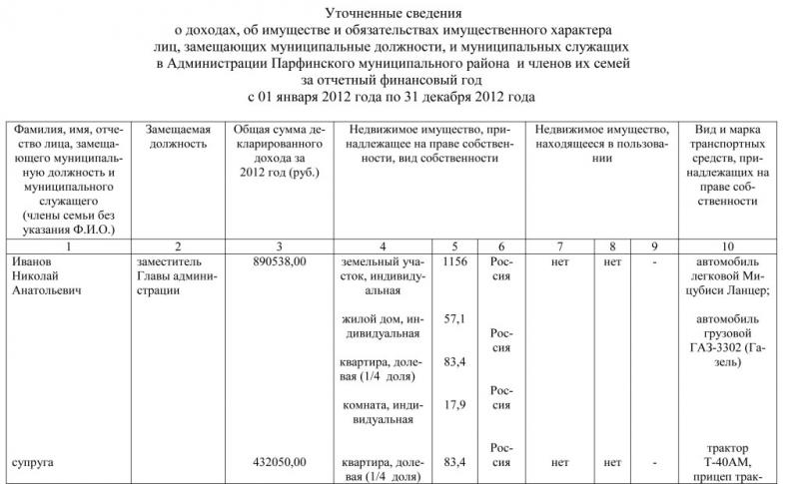](http://xn--80aqaedrljl1a.xn--p1ai/wp-content/uploads/Utochnennye-svedeniya-o-doxodax-rabotnikov-Administracii-municipalnogo-rajona-1.jpg)[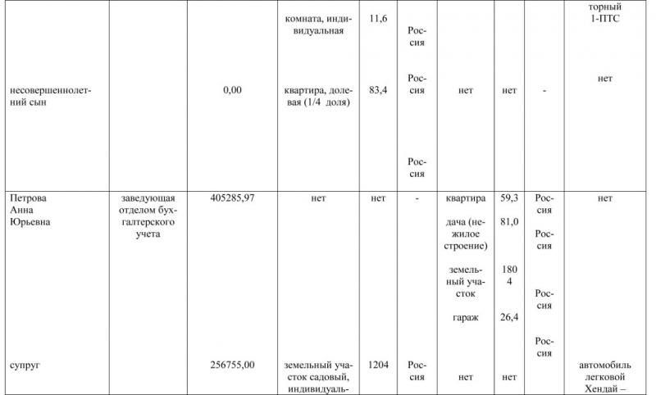](http://xn--80aqaedrljl1a.xn--p1ai/wp-content/uploads/Utochnennye-svedeniya-o-doxodax-rabotnikov-Administracii-municipalnogo-rajona-2.jpg)[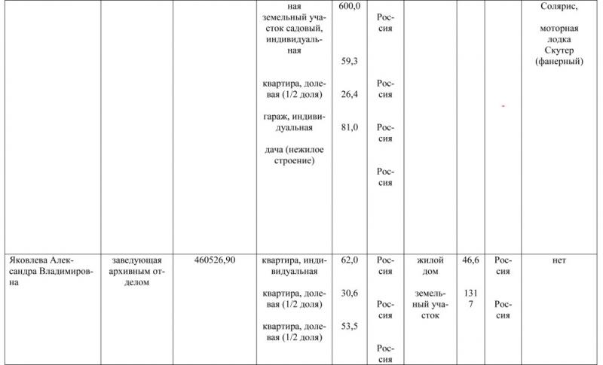](http://xn--80aqaedrljl1a.xn--p1ai/wp-content/uploads/Utochnennye-svedeniya-o-doxodax-rabotnikov-Administracii-municipalnogo-rajona-3.jpg)[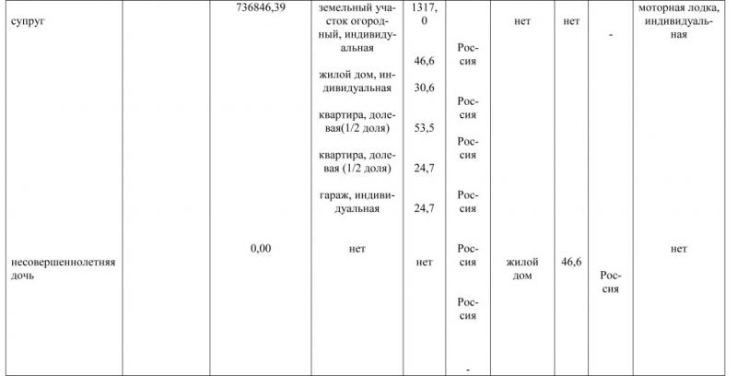](http://xn--80aqaedrljl1a.xn--p1ai/wp-content/uploads/Utochnennye-svedeniya-o-doxodax-rabotnikov-Administracii-municipalnogo-rajona-4.jpg)