[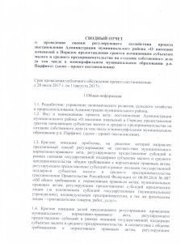](http://xn--80aqaedrljl1a.xn--p1ai/wp-content/uploads/svodnyj-otchyot-001.jpg) [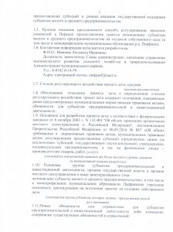](http://xn--80aqaedrljl1a.xn--p1ai/wp-content/uploads/svodnyj-otchyot-002-1.jpg) [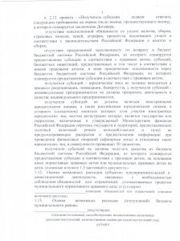](http://xn--80aqaedrljl1a.xn--p1ai/wp-content/uploads/svodnyj-otchyot-003.jpg) [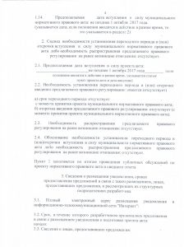](http://xn--80aqaedrljl1a.xn--p1ai/wp-content/uploads/svodnyj-otchyot-004.jpg) [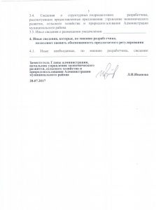](http://xn--80aqaedrljl1a.xn--p1ai/wp-content/uploads/svodnyj-otchyot-005.jpg)